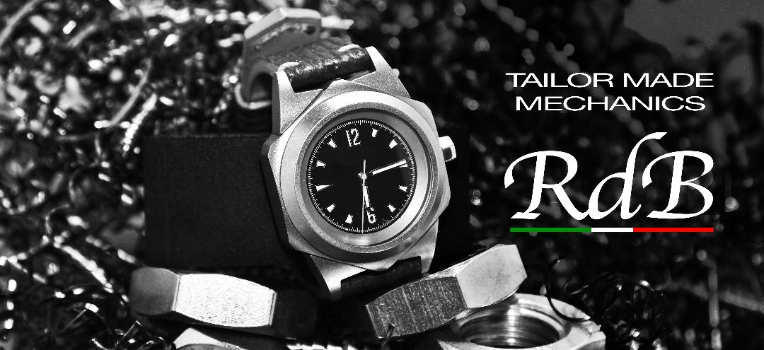

ErrediBi (RdB) – TAILOR MADE MECHANICS
ErrediBi is an independent manufacturer of built to order watches based in Brianza, between Monza and Lecco.
The original project dates back more than twenty years, with the deposit by the designer Franco Viganò of an invention patent for a double-cased watch derived from industrial components. The project also stood out among the pages of several watch magazines at the turn of the 2000s, unfortunately undergoing a sudden slowdown and in fact never being marketed.
Since 2017, together with the partner Guido Virginio Villa, the project has been dusted off, greatly refined in terms of quality and finally offered to the public.

A UNIQUE CASE
The outer body and the lower ring of the main watch body are obtained from an industrial hexagon nut measuring M24 (36mm) or M27 (41mm), while the internal body housing the movement is made from the relative screw.
The lugs are instead obtained through modern 5-axis CNC machines and mechanically applied to the body described above, a further unique feature in the world watch scene.
Careful processing of materials allows us to get all the details to proceed with the final assembly. All parts are obtained by machining from a solid piece on a machine tool.
Our watches are assembled in a completely opposite way compared to the classic wrist instruments: starting from the bezel, we go down to the case containing the movement: in this phase some seals of watchmaking derivation are inserted and a special design gasket derived from the 'mechanical industry.
Only the last stages are common assemblies in watchmaking.
The lugs are anchored to the external casing with truncated conical / cylindrical pins appropriately sized to ensure self-centering and positioning in the seat. Two for each lug for a total of 8 pins. Two of these, elongated, allow to engage the respective hemispherical seats on the inner casing and allow during the assembly phase the centering of the two existing cases, the anti-rotation during tightening and the phasing of the tige’s passage.
The entire production phase takes place in Brianza thanks to a pool of selected mechanical workshops.
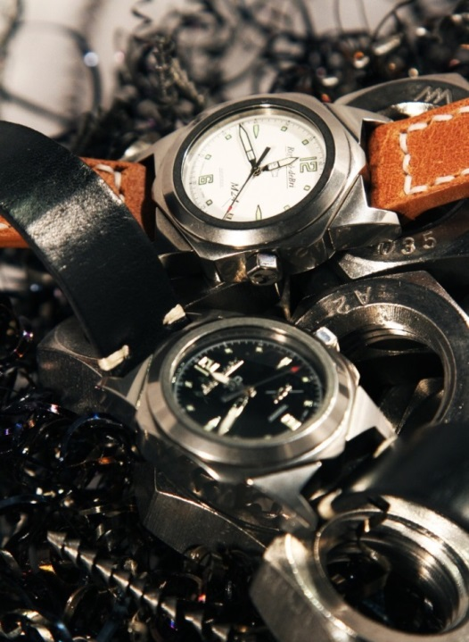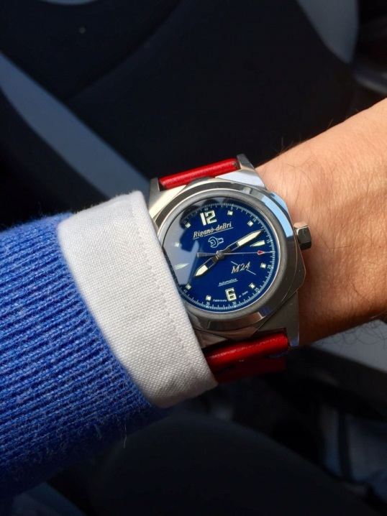

TAILOR MADE MECHANICS
The ability to fully customize your M24 or M27 according to your tastes is a peculiarity to which the unique architecture of our timepieces lends itself very well.
ErrediBi is pleased to offer this sort of Tailor Made Mechanics usually the prerogative of style exercises out of reach of the general public.
Our goal is to provide a high quality and unique product working on the imagination of the customer and creating an object that tells a personal story, going beyond the definition of a simple tool.
The customization potential has incredible flexibility with all our industrial heritage available.
Our watches generally come as unique and non-repeatable specimens, beyond small limited series.
Between the Customer and ErrediBi, a true relationship is established, giving way to a real adventure that will involve him in every part of the crafting of his unique piece, making use of the collaboration of different artisan realities of the territory .
In detail they are customizable:
• the size of the case, in variant M24 (36 x 50 mm) or M27 (41 x 53 mm)
• the case material, which can also be produced thanks to its particular nature (9 pieces, mechanically applied lugs) in different matched materials (lugs and bezel in one material and body in another for example). The materials currently machinable are: aluminum bronze - grade 5 titanium - ergal 7075 - titanium damascus - precious metals.
• the surface finish of the various parts, obviously also in different portions (polished, satin, pelleted, tumbled, etc.). In the case of Ergal anodized in any RAL color also in portions.
• the dial designed and produced in a one/one piece according to the tastes and needs of the customer.
• ad hoc personalized spheres and indices.
• laser engraving of symbols, drawings and phrases ad hoc on the back of the case.
• customized straps, stitching and buckles customized in leather type and working with tannery skins availability.
• dedicated and personalized theme packaging.

• movement to be cased, compatibly with the architecture of the internal casing.

The timepieces are equipped with an ETA 2671 caliber, in fact the only component not manufactured in Italy.
The straps are made by a well-known Italian craftsman and made specifically to measure in one/one piece.
The packaging is strictly made in Italy with an original magnetic box.

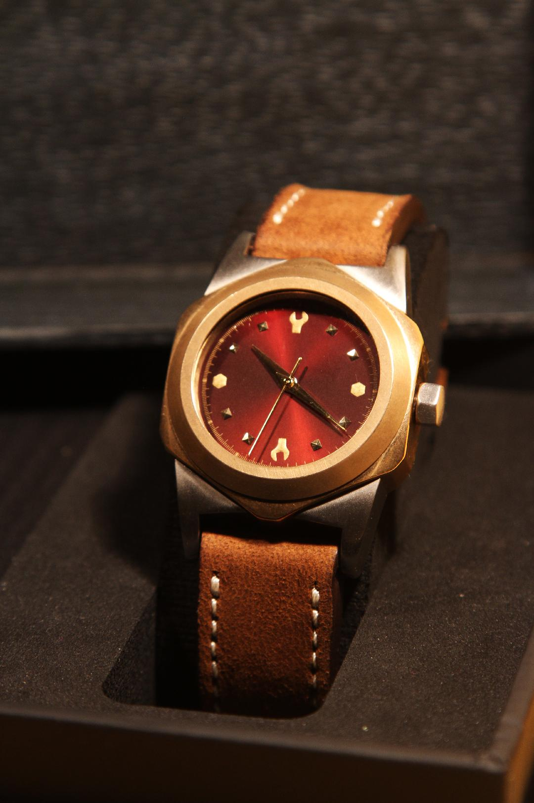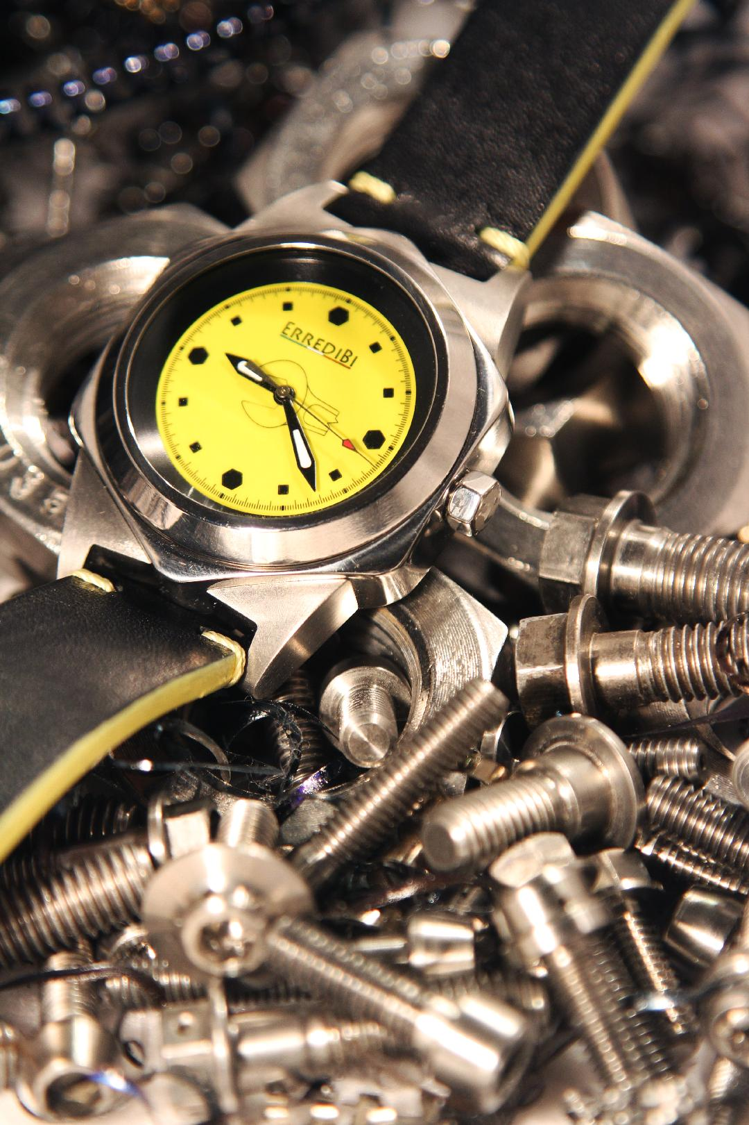

Thanks for your interest,

the ErrediBi team

